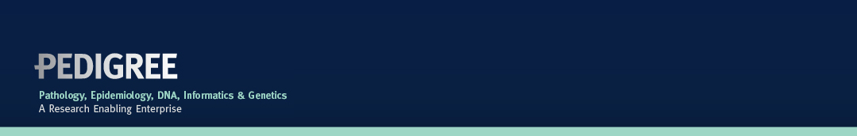

Project Progress Report

Lead Name:

Project Title:
Report Date:

Start Date:
Summarise the main progress achieved since either the commencement or submission of the previous progress report.

Have there been any changes to the project?

Additional comments, including comments on any difficulties encountered.

Planned or published articles

Expected completion date:

